**PHASE 2 - INNOVATION**

**DESIGN INTO INNOVATION AND THE STEPS INVOLVED IN IT’S IMPLEMENTATION**

**IoT-ENVIRONMENTAL MONITORING**

**HARDWARE REQUIREMENTS:**

* Temperature Sensors

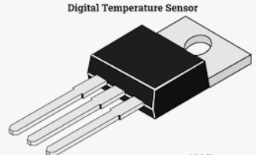

* Humidity Sensors

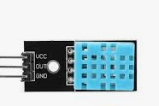

* Ultra Sonic Sensor

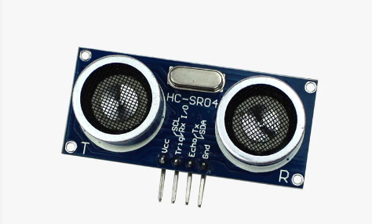

* IR Obstacle detection sensor

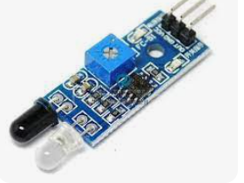

* Soil Moisture Sensors

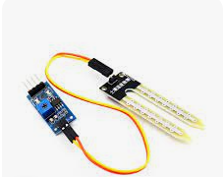

* LDR Photo-resistor

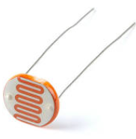

* Current and Voltage Sensors

**COMMUNICATION TECHNOLOGY:**

* LoRaWAN (Long Range Wide Area Network)

**SOFTWARE REQUIREMENTS:**

## Amazon Web Service

**OTHER REQUIREMENTS:**

* Wokwi online simulator

**STEPS OF IMPLEMENTATION:**

Step 1:

* **Sensor Deployment**

Deployment of the temperature sensors, humidity sensors, motion and presence sensors, water level sensors, water quality sensors, soil moisture sensors, light sensors, and current and voltage sensors in the target environment.

Step 2:

* **LoRaWAN Network Setup**

Setting up a LoRaWAN network infrastructure, which includes deploying LoRaWAN gateways and configuring them for sensor communication.

Step 3:

* **Sensor Integration**

Connection of the sensors to LoRaWAN nodes or modules compatible with the LoRaWAN network. Calibration of the sensors and ensuring they are configured correctly.

Step 4:

* **Data Transmission**

Programming of the LoRaWAN nodes to transmit sensor data at regular intervals to the LoRaWAN gateway. Ensuring that data is securely transmitted.

Step 5:

* **LoRaWAN Network Configuration**

Configuration of the LoRaWAN gateway to forward the sensor data to the LoRaWAN network server. Setting up necessary encryption and keys for secure communication.

Step 6:

* **LoRaWAN Server Configuration**

Configuration of the LoRaWAN network server to receive and process data from the gateway. Registration of the devices and creation of an application on the network server.

Step 7:

* **AWS Setup**

Creation of an AWS account and setting up the required AWS services for data storage, processing, and visualization. Services such as AWS IoT Core, Lambda, S3, DynamoDB, and QuickSight may be needed.

Step 8:

* **AWS IoT Core Configuration**

Registration of the LoRaWAN devices with AWS IoT Core. Configuration of the rules and actions to process incoming sensor data, including transformations and routing to other AWS services.

Step 9:

* **Data Storage**

Usage of Amazon S3 or DynamoDB to store the incoming sensor data. Creation of tables or storage buckets for data storage.

Step 10:

* **Data Processing**

Implementation of AWS Lambda functions to process and analyze the sensor data, including validation, aggregation, and other transformations.

Step 11:

* **Data Visualization**

Utilization of Amazon QuickSight or other AWS services to create dashboards and visualizations for real-time monitoring of environmental conditions.

Step 12:

* **Alerting and Notifications**

Setting up alerts and notifications in AWS to trigger actions when specific environmental conditions or thresholds are met.

Step 13:

* **Testing and Calibration**

Thoroughly testing the entire system to ensure data accuracy and reliability. Calibration of sensors if necessary for accurate measurements.

Step 14:

* **Deployment and Maintenance**

Deployment of the environmental monitoring system in the target environment. Continuously monitoring system performance and carrying out hardware and software maintenance.

Step 15:

* **Security Implementation**

Implementation of security measures to protect data and the system from unauthorized access. This includes encryption, access control, and regular security audits.

Step 16:

* **Documentation and Training**

Documentation of the system's architecture, configuration, and operation. Providing training to users and administrators as necessary.

Step 17:

* **Scalability and Future Enhancements**

Planning for the scalability of the system and considering future enhancements or the addition of more sensors and features as the project evolves.

**Visualization of historical temperature and humidity trends.**

### **Chennai Temperature History 2023**

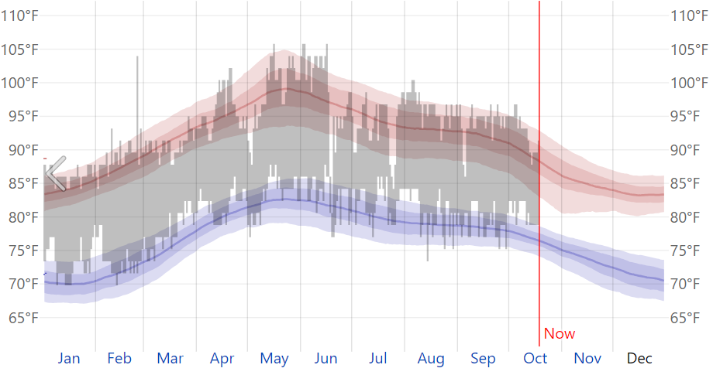

### **Humidity Comfort Levels in 2023 in Chennai**

